باقى اختبار ستيب
- The student to study vocabulary.
(had – has – should – must)
- The last exam was than the first one.
(easier – easy- the easiest)
- I my job three days ago.
( lost – am lost)
- Youssef lost entire graduation project his computer crashed .
( so _ when _ during _ although )
- If I have extra food , I always it to poor people .
( give – gave – given – giving).
- My vacation is being June 22.
(on – in – at)

- When I …………. The school, I shopping.
(finish/will go – finished/go)

- A: I don’t really like watching TV much. B: John doesn’t That’s why I watch it.
(so – either – neither – too)
- A: How do you feel?
B: Not good. I wish I that big meal lost night.
(didn’t have – wouldn’t have had – hadn’t had)



- Milk must cold to remain fresh.

(be kept – kept)

- I met my friend
the afternoon.

( in - on – at )

- I cut while cooking.

( myself – mine – me – I)

- Saud decide At home to day.
(to stay – to staying – stay)
- The student to study vocabulary.
(had – has – should – must)
- If I have extra food , I always it to poor people .
( give – gave – given – giving).
- Luxe’s cars by Japanese company.
( are made ).
- Ahmad's mother kept looking at him sympathetic while he lectured by his father.
(is - has been - was being - been ).
- Muhammad and ahmed enjoy spending time together
(themselves).
- I didn’t to the holiday last year.
(go – went – going)

- Ali is fixing brothers bicycle.
Then Ali Can they help him?
(he helps – is helping – was helping)

- What ……….. your’s job?
(does – is – do – has)

- water here.
(a – few – some)
- The city developed last few years, many new building…………..

(built – were built – have built – have been built)

- We football there days ago?
(played – have play – are played)

- Don’t take this book. It’s ………………

(mine – her – his – he)

- home.
(at – on – in)
- The cake was sitting on the table when the children… the class.
(enter – entered – entering)
- I my job three days ago.
  - ( lost – am lost)
  - Can you open the window?

We need …….….
(a fresh air – fresh air – an air fresh)

  - Saud decide At home to day.
(to stay – to staying – stay)

  - I arrived, he was talking on the phone.
(after – once – when – while)
  - Peter………at seven o'clock.
(gets up- is get up)

  - A: In our school they Stay behind late if we didn’t do our homework.
(made us – let us to – didn’t allow us – for cad as)

  - I…… visiting my parents next week? (am)
  - What she said?
She told me. the prescription.
(that l take - to take)

  - I visit king Saud library and I usually .............
(study – studying –studied –has studied)

  - I enjoy for friends.
( to cook – cook– cooking –to cooking)
  - I’d like… in Jeddah. It’s a very beautiful city.
( to live– live– living–lived)

  - If I a car, I would go to Makah right now.
( have –had– has– to have)

  - If I have a snack, I always them with my friends (Share)

  - In which sentence is all CAPITALIZATION correct ?

- Ahmad has three academic subjects in English French and Biology.

- Ahmad has three academic subjects in English, French and biology.

- Ahmad has three academic subjects in English, French and Biology.

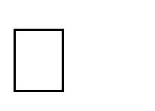

  - Russia is than Canada. ( bigger _ the biggest )
  - My sister is Anna, is eighteen years old.

( She_ he _ her )
  - Ahmed crashed computer he went to the computer repair shop.

( and- but- so- because ).
  - Children will sleep as soon as guests left.
( has- had- were- have)

  - When back from school tomorrow.

(are you come-have you coming-will you come)

  - Can i talk to the manager?

No, he to meet now.

(Is running)

  - forty day.

8) If ..........., said.
( for - since)

(had/would have).
- When you arrive at the airport tomorrow, someone for you at the checkpoint.

(will be waiting)

- Ahmed will fail the subjects he studies hard

( until -though-unless).

- Ahmed does not remember .

(Where the files are- where are the files).

- let me .

)

- In my opinion
money for cheap things.

( spending – to spend - spend ).

- I met my friend the afternoon.
( in - on – at )

- I cut while cooking.

( myself – mine – me – I)

- Tom has lived in this town Three years . ( for _ since _ in).
- I didn’t to the holiday last year.
(go – went – going)

- Ali is fixing brothers bicycle.
Then Ali Can they help him?
(he helps – is helping – was helping)

- The mechanic works on my car is very experienced.
(who – when – which – is)

- Does Mohammed… that the final exam is tomorrow .(know – knowing – is knowing)
- Saud decide At home to day.
(to stay – to staying – stay)
- I met my friend the afternoon
( in - on – at )
- If I have extra food , I always it to poor people .
( give – gave – given – giving).
- I my job three days ago.
( lost – am lost)
- Ahmad's mother kept looking at him sympathetic while he. lectured by his father.
(is - has been - was being - been ).

- None can ………you if you are not serious.
( helps–to help–helped– help)

- My father will arrive……….
( tomorrow– yesterday– last week– two days ago)
- Students from our university Red Sea last week.
  - a b. an c. the d. no article

- Do you know Mohammad? Yes, he is …… good person.
  - a b. an c. the d. no article

- Just last two years, all products in shops one sold days before Ramadan.
(are sold – sold – has sold – selling)

- Why don’t you eat sweets the… were bought by my father in turkey.
(were bought – had bought – has bought)??#

- The manager told his team that you can ask If you played the game well.
(yourselves – him – yourself)

- Have you seen the latest series movie of Turkey? I see every night.
(it – he – that )

- Ahmed is still thinking of becoming a manager He was failure to test.
(even though – even unless)

- My father died June 22
(on – at – in)
- If Khalid had watched that program, he it
(would enjoy –will enjoy – would have enjoyed)
- If they enough money , they would have built modern villas.
(had had-had-have) 38)) She can… it
(do – does)

- A: was John ready for his exam last week?
B: No, he… studied anything at all.
(hasn’t – hadn’t – didn’t – wasn’t)**

- When I…………… in Cairo, I my family
(arrived / called)
- Jeddah Rabigh . It’s a cosmopolitan city.
(the most interesting– is more interesting than– is more interesting– more interesting than)
42)Amal went to London................ .

(to learn- learn-learning)
- New jacket! Where you buy it? (did- were- are- is)

- What time back from school tomorrow.
(did you come- are you coming)

45) Fruit should ................. .

(be refrigerated)

- The box from recycled paper.
(made- was made- make)

- Seem ( to + v )

- Children went to sleep as soon as guests left.
(have- had-has been- were)

- Eating ice cream is bad for my health , I eat ice cream any more.
(shouldn’t _ mustn’t _ don’t have to)

- The student to study vocabulary.
(had – has – should – must)

- If I had extra food, I always……. it to the poor.
(give – gave – given)
- Mother’s sons said to them , eat your breakfast ………,they staffed their mouths until dishes get empty.
(however – since – so –as)

- Which one of the underline words or phrases is Incorrect? Ail and Majed has………………
( has)
- Go and ( bring)
- Let him ( leave)
- Want (to + v)
- What does mean this word Or What does this word mean ? what does this word mean

- I didn’t to the holiday last year.
(go not – went – going)
- The cake was sitting on the table when the children… the class.
(enter – entered – entering)

- Nayef makes breakfast while lunch …… by his wife (is made).

- I ………. My car. (am fixing).
- Choose the correct order to make the following sentences into a paragraph:

Children were playing out side the garden . They saw a honey bee .They let the bee go inside the garden.

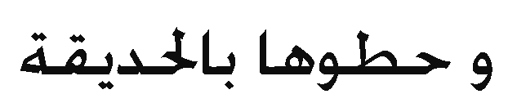



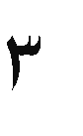

64/Choose the correct order to make the following sentences into a paragraph:

Last night in my home Ac Stopped working all my family members did not sleep well . The next day father called the mechanic he repaired . Our Ac now my home is quiet cold
Ac is start working .



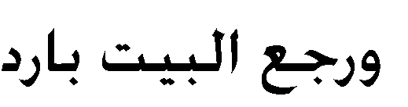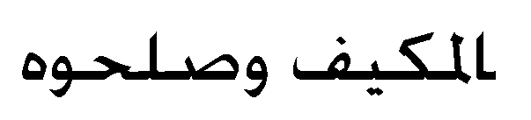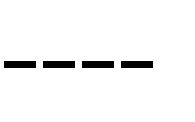





  - I met my friend the afternoon.

( in - on – at )

  - I cut while cooking.

( myself – mine – me – I)
  - Tom has lived in this town Three years .

( for _ since _ in).
\
  - If I have extra food , I always it to poor people .
( give – gave – given – giving).
  - What time back from school tomorrow.

(did you come- are you coming)

  - Choose the correct order to make the following sentences into a paragraph:

His mother wakes him up for fajer prayer .


He got up takes a bath prays fajer then he has his break fast He gets ready wears his uniform and goes to school ……

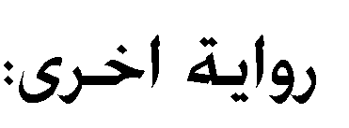

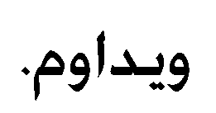

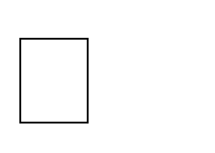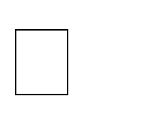

    - We need… butter to make this cake.
(some – any – much - many)

    - I lost my wallet in the mall, I walked asking, if anyone it
(had seen – had soon – has seen – have seen)

    - Where did go mike?
I don’t know where …………..
(went he – he went – did go he – he did go)

    - I have finished the quiz what?

We started the quiz for ten minutes ago.
You to finish the quiz so quickly
(couldn’t – shouldn’t – mustn’t – can’t - don’t have)

    - It is 3 P.M. I for over 30 minutes
(had waited – has waited – have waited)

    - Ali is fixing brothers bicycle.
Then Ali Can they help him?
(he helps – is helping – was helping)
    - I cut while cooking.

( myself – mine – me – I)
    - If I have extra food , I always it to poor people .
( give – gave – given – giving).
    - Ms. Amir,. the students call him Ms. Amir, thought boys physical activates
      - whom – b. which – c. he – d. him
    - home.
(at – on – in)

    - Can you open the window?

We need …….….
(a fresh air – fresh air – an air fresh)

    - children should learn to clean their own clothes .

    - did eat my sandwich?
( who)
(yours _ themselves)

- The student
to study vocabulary.
(had – has – should – must)

- If I had extra food, I always……. it to the poor. (give – gave – given)

- I met my friend
the afternoon

( in - on – at )

- The manager told his team that you can ask If you played the game well.

(yourselves – him – yourself)
- Tom has lived in this town Three years .
( for _ since _ in).

- malck is… than khaled. (smarter)
- Does Mohammed… that the final exam is tomorrow
(know – knowing – is knowing)

- Saud decide At home to day.
(to stay – to staying – stay)

24/ Choose the correct order to make the following sentences into a paragraph:

  - It is a heavy bird Ostrich cannot fly because of it heavy weight of an Ostrich .
  - The Ostrich is the largest bird in the world .
  - Approximate weight of an ostrich is around 1.5 Kg. a) ( 2 – 1 –3) b) ( 2 –3 –1)


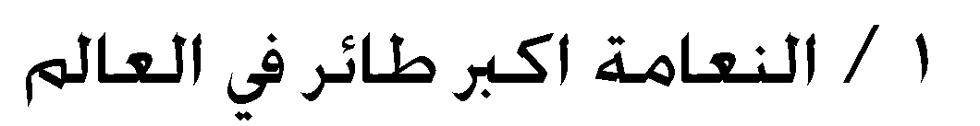


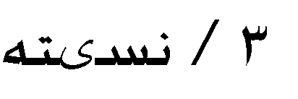


-


25/ Choose the correct order to make the following sentences into a paragraph:
kg
    - One hunter came and took their boat and went . 2)Two children were sitting under tree.

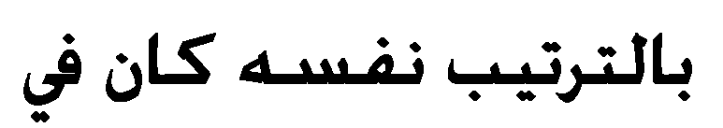

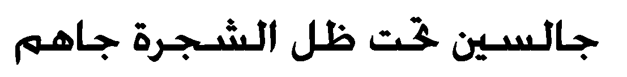


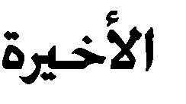
a) ( 2 _ 1) b) (1_2)

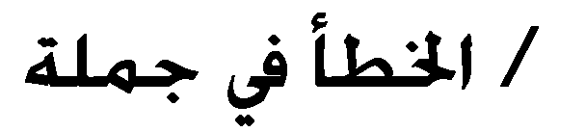
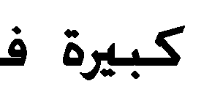

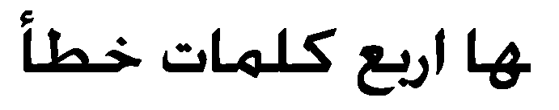
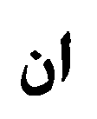
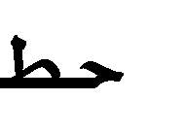
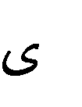

ARTICLES a waste time
26






)

- The student to study vocabulary. (had – has – should – must)
- If I have extra food , I always it to poor people .
( give – gave – given – giving).
- I met my friend the afternoon

time

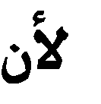
( in - on – at )
- I cut while cooking.

( myself – mine – me – I) 5)Tom has lived in this town Three years .

( for _ since _ in).

- September

( in)

- Milk must cold to remain fresh.

(be kept – kept)

- king Abdullah became the king, he gave the women opportunities.

(since– before)

- Ali is fixing brothers bicycle.
Then Ali Can they help him?

(he helps – is helping – was helping)

- Khalid always gets up 6 o’clock in the morning.
(on _ at _ for)

- I my job three days ago.
( lost – am lost)
- My vacation is being June 22.
(on – in – at)

- If my father was there,………….
(would help us)

- My teacher used to come to class with him……………
(few pens – some pens)

- My brother was athlete, he Before gained weight.
(was used to – is used to – used to)
- Where are you going?
I am to Super market.(running)

- Saud decide At home to day.
(to stay – to staying – stay)

- Have… of seeds and plants in their garden.
(a lot – many – much – plenty)

- I arrived, he was talking on the phone.
(after – once – when – while)
- I My car. (am fixing)**
- My father died June 22
(on – at – in)

- Identify the incorrect underlined word or words and mark your response on your answer sheet.

- My father he……………………………….
( he)

- Hana: Is that Dare’s?

Ahmed: No, it’s………..
(me – my – mine)
- If they enough money , they would have built modern villas.
(had had-had-have)

- If you… Me, I can get full marks.
(teach – teached – had teached)

- I…… visiting my parents next week? (am)
- you want more coffee.
(a lot – many – some –a)
- Khaled and Ahmad enjoy
- the manager we met in the city.
(whom – whose – which)

you should talk to………….
(her - her self - themselves )
- The chocolate cake . by the time my father come to home
( Did eat _ Had eaten _ was eating _ Eats ).
- The city developed last few years, many new building…………..
(built – were built – have built – have been built)
- The last exam was than the first one.
(easier – easy- the easiest)
- If I had extra food, I always… it to the poor.

(give – gave – given)
- A: it is Eric’s?
B: Yes,… (it is his –it
- New buildings developed last few years , many building ( built _ were built _ have built _ have been built ) .

- I prepare for my project author's books do you recommend

(which – who – that)
- We need… butter to make this cake.
(some – any – much - many)

- When I …………. The school, I shopping.

(finish/will go – finished/go)

- Arthur went to buy some… milk.
(many – more – much – some)
- What time back from school tomorrow .
( did you come _ are you coming ).

- Saud to learn the vocabulary words .
( should _ must _ can _ has )

- How did you respond when the police man asked you

him your driver’s license. ?
( give – to give – giving – to giving).

- Don’t take that book. It’s
( me – my – mine – myself).
- What are you doing home?
( in _ at _ to _ on).

- Mike decided at home tonight .
( to staying _ to stay _ stayed _ stay)

- Which one of the underline words or phrases is Incorrect?

Young children love jump , running , skipping , and tumbling to practice their growing motor skill. Furthermore , they develop a better sense of balance and increase in confidence when their skills improve over time.

( jump – their – furthermore – overtime).
- - must wear a seat belt .

( everybody _ anybody _ anyone – everything).

- I. my pen lost .

( have – has ).

- The weather very cold .

( enough _ too)
- I normally takes munities shave , but today I’m taking my time

( much _ lot of - a few )

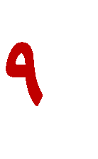

)
- The student to study vocabulary. (had – has – should – must)
- If I have extra food , I always it to poor people .
( give – gave – given – giving).
- I met my friend the afternoon

( in - on – at )
- I cut while cooking.

( myself – mine – me – I)

- Tom has lived in this town Three years .

( for _ since _ in).
- September

( in)
- Milk must cold to remain fresh.

(be kept – kept)
- king Abdullah became the king, he gave the women opportunities.

(since– before)

11) I my job three days ago.
( lost – am lost)
- My vacation is being June 22.
(on – in – at)
- If my father was there,………….
(would help us)
- My teacher used to come to class with him……………
(few pens – some pens)
- My brother was athlete, he Before gained weight.
(was used to – is used to – used to)
- Where are you going?
I am to Super market.(running)
- Saud decide At home to day.
(to stay – to staying – stay)

- Have… of seeds and plants in their garden.
(a lot – many – much – plenty)
- I arrived, he was talking on the phone.
(after – once – when – while)
- Identify the incorrect underlined word or words and mark your response on your answer sheet.
  - My father he……………………………….
( he)

- Let’s me… ( V1)

- Jeddah on red sea.

- I don’t to holiday.

(located – is located)

(go)

- ALRajhi Bank is bank Olya.

in

- After Ahmad graduates next year, he ( ) your family and married

( helps _ helped _ will help – has helped)

- All ( ) must be kept medicine.

( Hospital – hospitals - hospital's- hospitals 's )

- I tried ( to V1).

- Too + subject + ( to V1) .

- To take ( these) money to bank .

- I am tried ( so) I will take a shower and sleep .

- I take of ( V-ing ) .

- Hind ( less money than) Fatimah .


- He drive ( ly )

- what gaves ( her) as gift.

- I ( am) fixing my car .

- Eating ice cream is bad for my health , I eat ice cream any more.

(shouldn’t _ mustn’t _ don’t have to)
- Choose the correct order to make the following sentences into a paragraph:

Our body needs carbohydrate and proteins fat ……
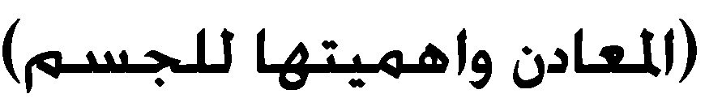
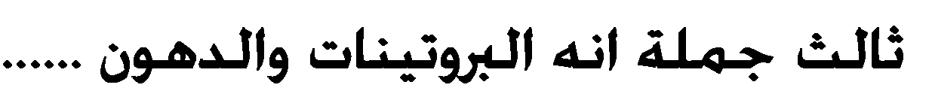

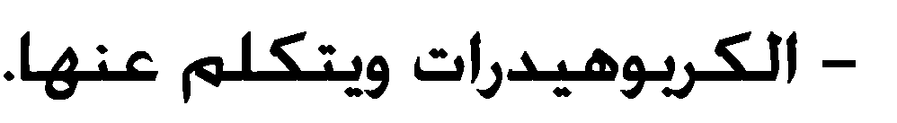


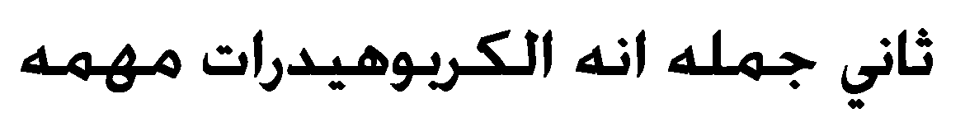
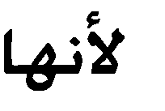
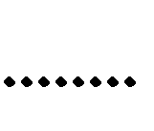
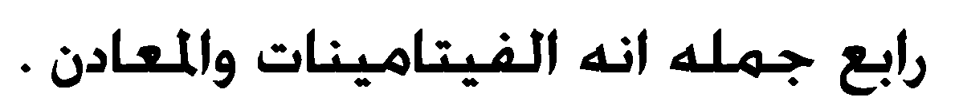






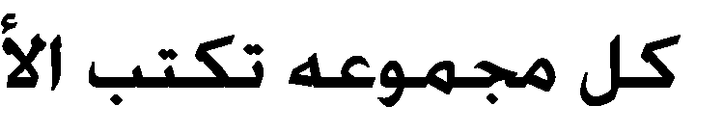

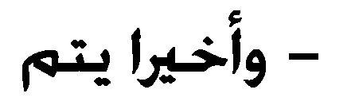
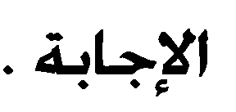
Business is divided into group. Every group has its leader Each group has to write the queries and send it to their leader.

